
SCHOOL OF COMPUTING AND ENGINEERING SCIENCES (SCES)
BACHELOR OF SCIENCE IN ELECTRICAL AND ELECTRONICS ENGINEERING (BSEEE)
SEMESTER ONE: FLUID THEORY EXPERIMENT.
By
Mwongela Edward Aribu 142092
Collaborators
Trevor atela 1
Mitchelle gichamba
Jessica olyang’
Antonio njemela

Contents
CHAPTER 1. 4
Introduction: 4
Objectives: 4
Apparatus: 4
CHAPTER 2 5
Theoretical background 5
CHAPTER 3. 7
Experimental Setup 7
Procedure: 7
CHAPTER 4. 8
Observations: 8
Specification of glass tube 8
Radius of the steel ball 8
Density of the sample liquid: 8
Density of the steel ball 8
Determination of viscosity 9
Precautions: 9
CHAPTER 5. 10
CONCLUSION. 10

ABSTRACT

This is a report that was made following an experiment on viscosity of fluids which comprised of water and castor oil. The aim of the experiment was to test the difference in the speed of bearings with different masses when dropping in different fluids.

CHAPTER 1.

Introduction:
Viscosity is a measure of the resistance of a fluid which is being deformed by either shear stress or tensile stress. In everyday terms (and for fluids only), viscosity is “thickness”. Thus, water is “thin”, having a lower viscosity, while honey is “thick”, having a higher viscosity. Put simply, the less viscous the fluid is, the greater its ease of movement (fluidity). In general, in any flow, layers move at different velocities and the fluid’s viscosity arises from the shear stress between the layers that ultimately opposes any applied force.
In a Newtonian fluid, the relation between the shear stress and the strain rate is linear with the constant of proportionality defined as the viscosity. In the case of a non- Newtonian fluid, the flow properties cannot be described by a single constant viscosity. Some non-Newtonian fluids thicken when a shear stress is applied (e.g., corn flour suspensions), whereas some can become runnier under shear stress (e.g., non-drip paint). Industrially, understanding the viscous properties of liquids is extremely important and relevant to the transport of fluids as well as to the development and performance of paints, lubricants, and foodstuffs.

Objectives:
To measure the viscosity of a sample liquid.

Apparatus:

- Glass tube
- Steel balls
- Retort stand and clamps
- Weighing balance
- Screw gauge
- Stopwatch
- Sample liquid (castor oil/glycerin)
- Tweezers
- Rubber bands for marking calibration points
- Cleaning accessories

CHAPTER 2

Theoretical background
A body moving in a fluid feels a frictional force in a direction opposite to its direction of motion. The magnitude of this force depends on the geometry of the body, its velocity, and the internal friction of the fluid. A measure for the internal friction is given by the dynamic viscosity η. For a sphere of radius r moving at velocity vin an infinitely extended fluid of dynamic viscosity η, G.G. Stokes derived an expression for the frictional force.
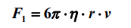

If the sphere falls vertically in the fluid, after a time, it will move at a constant velocity v, and all the forces acting on the sphere will be in equilibrium (Fig. 1): the frictional force F₁which acts upwards, the buoyancy force F₂ which also acts upwards and the downward acting gravitational force F₃. The two forces F₂ and F₃ are given by:

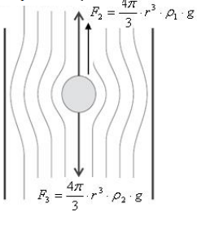

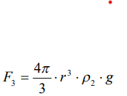

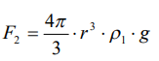
where ρ = density of the fluid
ρ ₂= density of the sphere.
g= gravitational acceleration

The equilibrium between these three forces can be described by:

F1 +F2 + F3(4)

The viscosity can, therefore, be determined by measuring the rate of fall ‘v’:

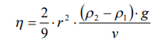
where v can be determined by measuring the fall time t over a given distance s.

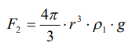
In practice, equation 5 must be corrected since the assumption that the fluid extends infinitely in all directions is unrealistic and the velocity distribution of the fluid particles relative to the surface of the sphere is affected by the finite dimensions of the fluid. For more accurate values of viscosity wall effect need to be considered. The modified expression for high viscous liquids with the correction is as follows:

While Stokes’ Law is straight forward, it is subject to some limitations. Specifically, this relationship is valid only for ‘laminar’ flow. Laminar flow is defined as a condition where fluid particles move along in smooth paths in lamina (fluid layers gliding over one another). The alternate flow condition is termed ‘turbulent’ flow. This latter condition is characterized by fluid particles that move randomly in irregular paths causing an exchange of momentum between particles.

Units: The SI physical unit of viscosity is Pascal-second (Pa.s, equivalent to N.s/m²or kg/ms). The CGS unit is poise (P), named after Jean Louis Marie Poiseuille. It is more commonly expressed as centipoise (cP) or milli Pascal-second (mPa.s). The conversion factor is 1cP = 1mPa·s = 0.001Pa·s. 1 Poise = 100 centi Poise. Castor oil at room temperature has a viscosity of ~ 650 cP or ~0. 65N.s/m².

CHAPTER 3.

Experimental Setup

The experimental set up, shown in Fig. 2, is based on Stokes’ Law. It is filled with the sample liquid under investigation. A steel ball is allowed to fall down this tube over a calibrated distance. The falling time is recorded and then utilized to determine the viscosity at room temperature.

Procedure:

- Measurement of diameter of falling ball:

Determine the least count (vernier constant) of the screw gauge.
Measure the radii of at least three balls using the screw gauge.

- Measuring the falling times:

Carefully clamp the glass tube to the retort stand and make sure it is vertically aligned.
Choose marked calibrated positions and ensure that the ball indeed falls with terminal velocity. Pick one of the given balls and roll it in the sample liquid to wet its surface thoroughly before dropping into the glass tube.

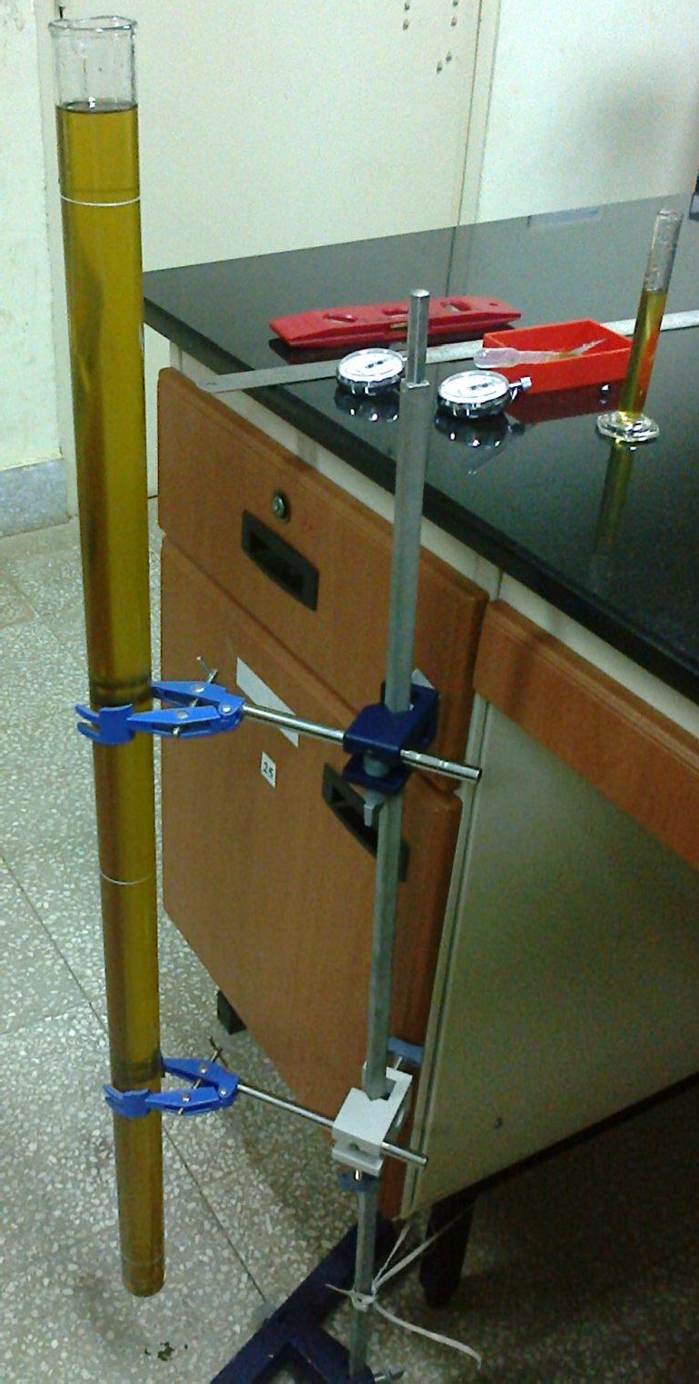
Fig. 2

Keep two stopwatches ready to measure the fall time between two different calibrated positions.
Bring the ball with a tweezers over the tube and drop it carefully into the liquid at the center of the tube.
Watch the ball falling centrally through the liquid. When it reaches the first calibration mark, start both the stopwatches. Note down the time taken by the ball separately to reach the second and third calibration marks.
Measure the falling times similarly for all the balls supplied to you.
Measure the distance from first to second and third calibration marks to determine the terminal velocity.
Finally calculate viscosity using the correction as given in Eq. 6.

CHAPTER 4.

Observations:

Specification of glass tube
Inner diameter of the measuring tube = 2.88±0.01 cm
Length of the cylinder = cm

Radius of the steel ball
Vernier constant of screw gauge = …….

Observation # | Linear scale  reading | Circular scale  reading | Total reading | Average radius
1 | 1.7 | 0.007 | 1.77
2 | 1.3 | 0.05 | 1.35
3 | 0.9 | 0.05 | 0.95

Density of the sample liquid:
Calculated density of sample liquid, ρ1= 1.26 ± 0.01 g/cc

Density of the steel ball
Least count of weighing balance = …………….

Observation # | Mass | Average Mass | Average  density, ρ  2
1 | 23.76 |  | 8.183  6.513  6.104
2 | 8.39
3 | 2.74

Determination of viscosity
Distance between 1st and 2nd calibration mark = ……5cm……
Distance between 1st and 3rd calibration mark = ………10.3cm…
Least count of the measuring scale = …….

Ball # | Falling time from 1st to 2nd  calibration mark, t₁ | Falling time from 1st to 3rd  calibration mark, t₂ | Velocity between 1st and 2nd  calibration mark, v₁ | Velocity between 1st and 3rd  calibration mark, v₂ | Average terminal velocity, v | Average viscosity with correction,  η
1 | 0.023 | 0.053 | 2.17 | 1.94 | 2.055  3.44  3.64 | 0.1063
2 | 0.012 | 0.038 | 4.17 | 2.71
3 | 0.013 | 0.03 | 3.85 | 3.43

Error estimation: Estimate the propagation of error and report it with the result.

Precautions:
  - Avoid contaminating the balls, use tweezers or tissue paper to hold the balls.
  - Drop the balls centrally into the sample liquid.

CHAPTER 5.

CONCLUSION.
The viscosity that is experienced by a falling object in increases with many factors such as:
- Geometric factor.
- Mass
- weight

Reference for wall correction: A.W.Francis, A.D.Little, Journal of Applied Physucs, 1933, vol.4, page.403-406

